

COMPANY PROFILE

**ABOUT US**

**EXCELLENCE TECHNOLOGY (ET)** is India based leading strategic IT Company offering integrated IT solutions with the vision to provide Excellence in software solution. We at EXCELLENCE TECHNOLOGY bring innovative ideas and cutting edge technologies into business of customers. EXCELLENCE TECHNOLOGY is having rich experience in providing high technology end to end solutions in **MOBILE APP AND WEB DEVELOPMENT.**

4

**PHILOSOPHY**

* To impart hardcore practical quality training among students/developers about latest technologies trending today.
* To share knowledge of information security and create awareness in the market. The solution to clients' as per the International standard practices and governance.
* To support good business practices through continual employee training and education
* To equip a local team with a strong knowledge of international best practices and international expert support so as to provide practical advisories in the best interests of our clients

**OUR MISSION**



To Protect Client's information system by

Detecting Threats, Deterring Attacks, and provide best solution in the ever changing

Info - Security Challenges. We accomplish this by integrating our People, Process, and Technology in the most efficient way to increase value for all stakeholders

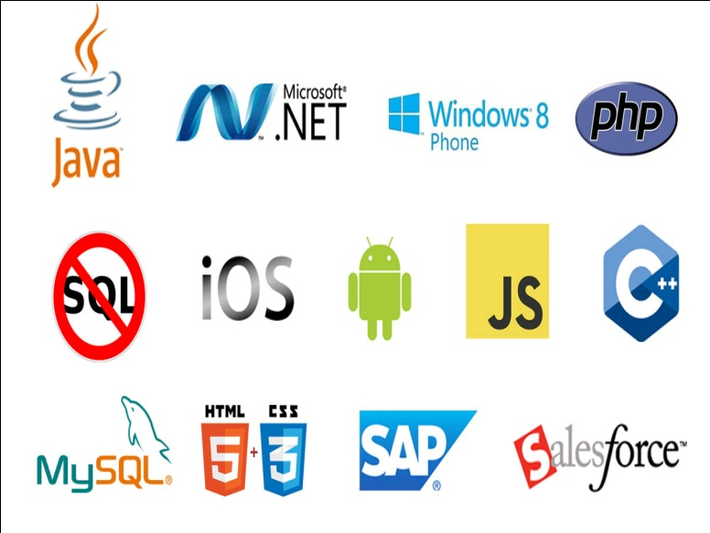**OUR SERVICES**

* RISK Management Services
* Quality Control
* Business Process Re-Engineering
* Network Risk Analysis
* Software Testing
* Mobile Application Testing
* Wireless Penetration Testing
* Network Penetration Testing
* Application Security Testing

**OUR SERVICES IN SOFTWARE DEVELOPMENT**

***We are proficient in all platforms of software Development practices — Agile, SCRUM, Lean, Waterfall, Prototype, Incremental, Iterative, and V-Model.***

With the EXCELLENCE TECHNOLOGY experience the incredible services such as agile software development and the problems related to outsourcing. We comprise of the team of experienced and professionals members who with their skills efficiently get the job done and innovatively help you to transform your ideas into the successful business.



Why Choose Us?

* **Hundreds of Clients & Nearly a Decade of Experience**
* **Goal Oriented, ROI-Driven Focus**
* **A Streamlined / Quality-Driven Process**
* **Talented Designers & Expert Developers**
* **Our Websites & E-marketing Platforms are Easy to Manage**
* **We Are Dedicated to Our Clients’ Success**
* **EXCELLENCE TECHNOLOGY** is steadfast to undertake the projects cutting edge to technology competence and know-how abilities. The project execution is held with dedication and responsibility to perform our best with the essence of knowledge, creativity and skills to the utmost and efficiently.
* At **EXCELLENCE TECHNOLOGY,** we have competence to expand and adjust as per client specific requirements.
* **Skilled Workforce:** At EXCELLENCE TECHNOLOGY you deal with the highly professional and proficient employees.
* **Cost Efficiency:** We help you to reduce the unnecessary investment and ask for the reasonable amount of money.
* **Quality Of the Product:** Our software service sector has been maintaining the highest international standards of quality.
* **Infrastructure:** Well organized team and tools to handle the projects with responsible approach Hardware, Software, Networking, Voice, Conferencing, disaster recovery all infra all you need for international projects.
* **Ongoing Involvement:** EXCELLENCE TECHNOLOGY products are “built for change” as we are well responsive that the necessity to improve a Web solution generally arises even before the solution is out of the door. We delivers long-term product enhancement if desired.
* **Partnership:** EXCELLENCE TECHNOLOGY considers every client a partner. From the initial stages, you are closely involved into the procedure of technical classification, development, and testing.

**OUR CLIENTS**

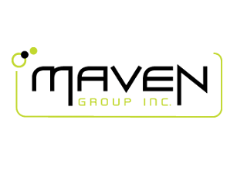

**KEY PROFESSIONALS:**

In addition to a panel of eminent consultants and advisors, we have a dedicated pool of trained Developers and Trainer, investigators, working under the guidance of professional managers. **“A Ship is as good as the crew who sail her**.**”** Our Technical team of professionals handing, designing & delivering of projects has a strong presence in the North India & the US. Our engineers are already working on the latest technologies like **I-Phone & Android** Applications, **Robotics**, **VLSI-VHDL**, Embedded System, Networking and **Cloud computing.** Some of the key professionals and advisors are listed below:

**Mr. Deepak Kashyap:** (**Branch Manager**)

He is the backbone of Excellence Technology and a man with more than 10 year rich practical experience who believes in taking up new ventures and projects. Head-IT, Global Award Winner from India for AGILE and OPEN GRAPH implementation in **Sudan Taxation Chamber**. Divisional Award and Star Award Winner in Year 2011 for his exemplary work in process improvement for IT Service Delivery Domains. MASTERS in Computer applications and Certified from PTU Certification. Holds total of 10 Years of rich experience including 5 Years in Information Security Implementation, Maintenance and Auditing and initial over 10 years experience in Project Management, Client Relationship Management and Server, Desktop and IT Service Delivery.

**Ms. Sunita Thakur :** (**Dean Academics**)

AWoman who believes that “Honour Time & Place, then you will be honored.” She has more than 4 years solid industrial experience in a software companies & is very dashing and innovative in her technical approach.MCA, Diploma in Information Technology, expertise in search engine optimization and webdesigning.

**Mr. Gurpreet Singh : (Technical Head - Python & GIT HUB)**

A man who strongly feel that “Nothing is Impossible”. A very committed team leader who has been professionally attached with Multinational companies for more than 18 years and has lead the marketing teams in all states of North India.MCA (Engineering),in computer Science PTU Approved trained and Certified. Successfully MCA master degree Training program for a leading Technology. Holds total of 5 Years of rich experience including 3 Years in Software developer, Maintenance and Auditing and initial over 4 years experience in Project Management, Client Relationship Management and IT Service Delivery.

**Miss. Anjali Sharma : (Sr. Counselor)**

A woman who believes that “Challenges are what make life interesting and overcoming them is what makes life meaningful.” She has more than 3years experience in business development.B.A. – (Punjab University) Lead Consultant - Due Diligence, Strategy, Operations, Business Continuity, Risk Management, Mergers & Acquisitions.

**Mr. Akshit Dogra : (Mechanical Head)**

A man believes that “don’t wait for extra ordinary opportunities, seize common occasions and make them great.” He has more than 4 years experience in marketing field.B.Tech (Mech), Engineer and Value, is a approved by AICTE (HPTU). He is having total 5 years of experience in 3 years of experience in Autocad, Solidworks, Catia, Pro-e, Ansys etc.

**Mr. Paramveer Singh : (Mobile Application & Web Developer)**

B.Tech(CSE) – IKG-PTU, Expertise in Reviewing current systems, Presenting ideas for web development soft wares, including Application softwares, Working closely with analysts, Senior Developers, Programmers, designers and staff, Producing detailed specifications and writing the program codes, Testing the product in controlled, real situations before going live, Preparation of training manuals for users and Maintaining the systems once they are up and running

**Corporate Office:** C-133, First Floor

Industrial Area, Phase-8, Sector-72, Mohali .

**PH.**:0172-4698755,93177-88822 ,93562-55522

**E-MAIL**: excellencehead@gmail.com,

**URL:** www.excellencetechnology.in

## ACKNOWLEDGEMENT

I am highly grateful to the Dr. Manoj Kumar , Principal, DAV Institute of Engineering & Technology, Jalandhar, for providing this opportunity to carry out the six month industrial training at excellence technology company.

The constant guidance and encouragement received from Ms. Harpreet Kaur Bajaj, HoD Department of Computer Science & Engineering, DAVIET Jalandhar has been of great help in carrying out the project work and is acknowledged with reverential thanks.

I would like to express my gratitude to Ms. Sonali, Assistant Professor Department of Computer Science & Engineering DAVIET Jalandhar for his stimulating guidance, continuous encouragement and supervision throughout the course of present work.

I would like to express a deep sense of gratitude and thanks profusely to Ms. Sunita

Thakur Director/CEO of Company ,. Without the wise counsel and able guidance, it

would have been impossible to complete the report in this manner.

The help rendered by Mr. Deepak Kashyap, Designation technical head in company excellence technology for experimentation is greatly acknowledged.

I express gratitude to other faculty members of Computer Science & Engineering department of DAVIET for their intellectual support throughout the course of this work.

**Name of the Student**

Bhawana

**Project Title:**

Emotion-Detection

**Introduction:**

This project aims to classify the emotion on a person's face into one of **five categories**, using deep convolutional neural networks. The model is trained on the **FER-2013** dataset which was published on International Conference on Machine Learning (ICML). This dataset consists of 35887 grayscale, 48x48 sized face images with **five emotions** 'Angry' ,'Happy' , 'Neutral ','Sad' and 'Surprise'

Emotion detection has become a topic of continuous research and innovation as over the past decade the limitations of computer vision have been lifted by the introduction of machine learning. As machine learning algorithms leverage the huge computation power of GPU’s, the image processing capabilities of these models fit suitably with real world problems. Computer vision has spread from a novel domain to several other domains such as the behavioural sciences. These algorithms or models are being used in various real-world applications across several fields such as security, driver-safety, autonomous vehicles, human-computer interaction and healthcare. These models are continuously evolving due to the introduction of graphical processing units which are hardware equipment’s capable of performing millions of computations within mere seconds or minutes. The emergence of technologies such as augmented reality and virtual reality are also dependent on these GPU’s heavily. Hence, combining the statistical intelligence of machine learning algorithms and the processing power of GPU hardware, we are able to create breakthrough models capable of detecting emotions from static images as well as video feeds.

The project work entitled "Facial Emotion Detection Using Machine Learning" would envisage the following:

Capturing static images for pre-processing.

Feature Extraction using Deep Neural Networks.

Implementing a convolutional neural network to classify images based on the aforementioned features

**DATASET:**

This model is capable of recognizing seven basic emotions as following:

1. Happy
2. Sad
3. Angry
4. Surprise
5. Neutral

The FER-2013 dataset consists of 28,709 labelled images in the training set and 7,178 labelled images in the test set. Each image in this dataset is labelled as one of seven emotions: happy, sad, angry, afraid, surprise, disgust, and neutral. The faces have been automatically registered such that the face is more or less cantered and occupies about the same amount of space in each image.

In this project, we will be using Deep Learning(CNN) and Computer Vision.

**WHAT IS DEEP LEARNING:**

Machine Learning (ML) and Deep Learning are subsets of Artificial Intelligence. Deep Learning represents the next evolution in Machine Learning. In Deep Learning, the model learns through an artificial neural network that is very much similar to a human brain and this allows the model to analyse data in a structure much similar to humans do. Deep Learning models don’t require a human programmer to intervene and tell what to do with the data. It is self-capable of learning from the extraordinary amount of data provided to it.

Deep learning is a machine learning technique that teaches computers to do what comes naturally to humans: learn by example. Deep learning is a key technology behind driverless cars, enabling them to recognize a stop sign, or to distinguish a pedestrian from a lamppost. It is the key to voice control in consumer devices like phones, tablets, TVs, and hands-free speakers. Deep learning is getting lots of attention lately and for good reason. It’s achieving results that were not possible before.

In deep learning, a computer model learns to perform classification tasks directly from images, text, or sound. Deep learning models can achieve state-of-the-art accuracy, sometimes exceeding human-level performance. Models are trained by using a large set of labelled data and neural network architectures that contain many layers.

In a word, accuracy. Deep learning achieves recognition accuracy at higher levels than ever before. This helps consumer electronics meet user expectations, and it is crucial for safety-critical applications like driverless cars. Recent advances in deep learning have improved to the point where deep learning outperforms humans in some tasks like classifying objects in images.

While deep learning was first theorized in the 1980s, there are two main reasons it has only recently become useful:

Deep learning requires large amounts of labelled data. For example, driverless car development requires millions of images and thousands of hours of video.

Deep learning requires substantial computing power. High-performance GPUs have a parallel architecture that is efficient for deep learning. When combined with clusters or cloud computing, this enables development teams to reduce training time for a deep learning network from weeks to hours or less.

**What is a Neural Network?**

A neural network is a series of algorithms that endeavours to recognize underlying relationships in a set of data through a process that mimics the way the human brain operates. In this sense, neural networks refer to systems of neurons, either organic or artificial in nature. Neural networks can adapt to changing input; so the network generates the best possible result without needing to redesign the output criteria. The concept of neural networks, which has its roots in [artificial intelligence](https://www.investopedia.com/terms/a/artificial-intelligence-ai.asp). is swiftly gaining popularity in the development of [trading systems.](https://www.investopedia.com/articles/trading/11/automated-trading-systems.asp)

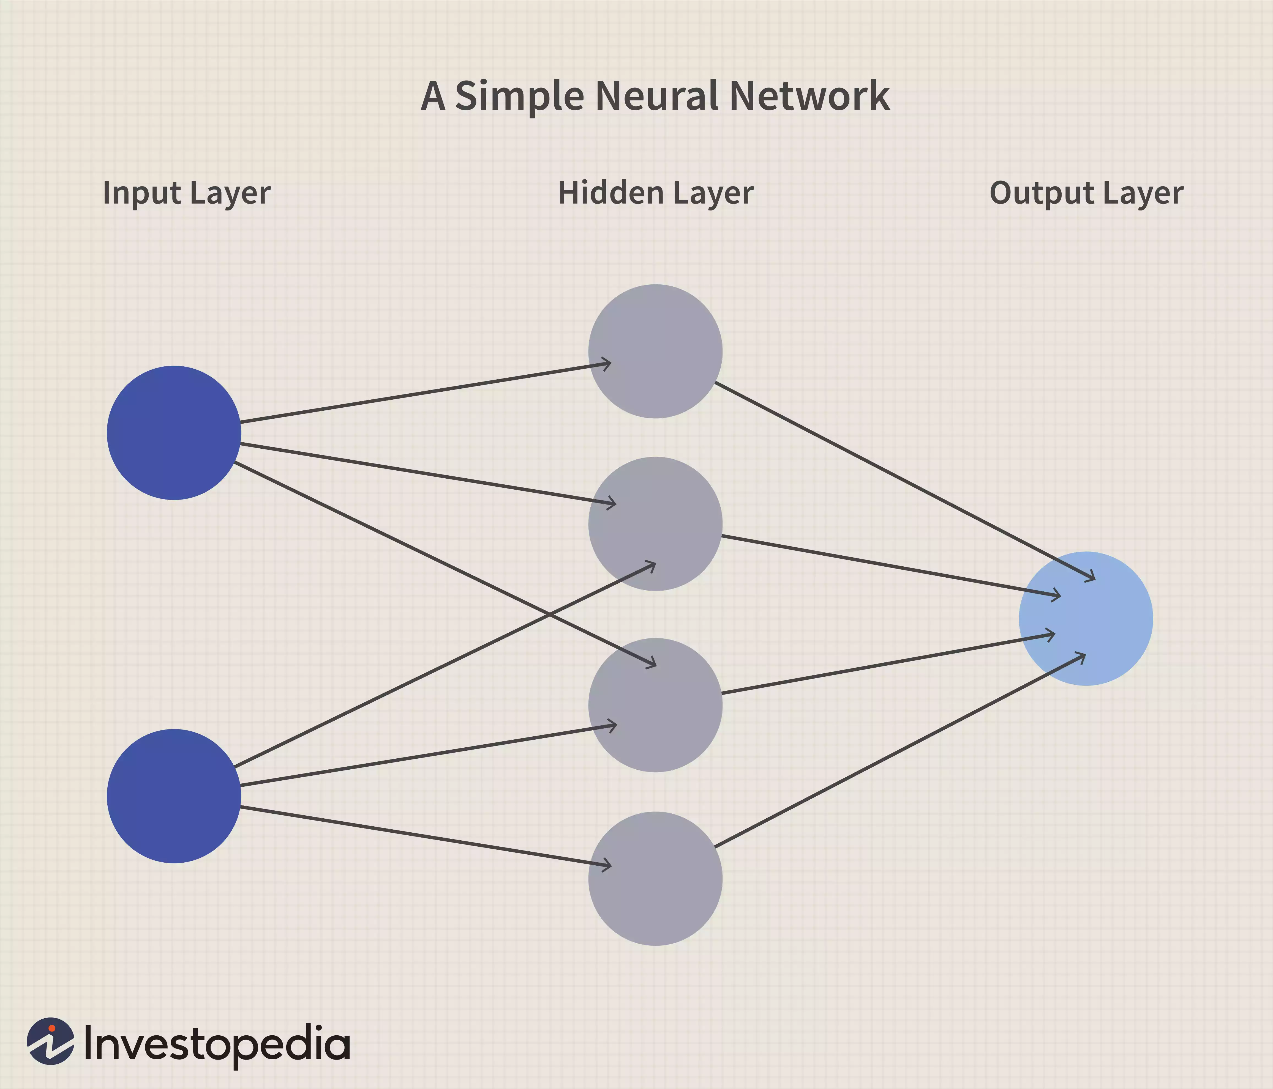

**Basics of Neural Networks**

Neural networks, in the world of finance, assist in the development of such process as time-series forecasting, [algorithmic trading](https://www.investopedia.com/terms/a/algorithmictrading.asp), securities classification, credit risk modeling and constructing proprietary indicators and price [derivatives](https://www.investopedia.com/terms/d/derivative.asp).

A neural network works similarly to the human brain’s neural network. A “neuron” in a neural network is a mathematical function that collects and classifies information according to a specific architecture. The network bears a strong resemblance to statistical methods such as curve fitting and regression analysis.

A neural network contains layers of interconnected nodes. Each node is a perceptron and is similar to a [multiple linear regression](https://www.investopedia.com/terms/m/mlr.asp). The perceptron feeds the signal produced by a multiple linear regression into an activation function that may be nonlinear.

**COMPUTER VISION:**

Computer vision provides the ability for the computer to see as humans see. It is the part of computer science that is focused on replicating the intricate parts of the human visual system. It helps identify and process the objects in images through the computer.

Deep learning has delivered superhuman accuracy for image classification, object detection, image restoration, and image segmentation. It uses enormous neural networks to teach machines how to automate the tasks performed by human visual systems. It is a field that aims to gain a deep understanding through digital images or videos.

**INTRODUCTION TO OpenCV:**

There are some predefined packages and libraries in python as part of Computer Vision which can make our life quite simple and OpenCV is one of them. It helps us develop a system that can process images and real-time video using computer vision. OpenCV (Open Source Computer Vision Library) is an open-source computer vision and machine learning software library which is easy to import in Python. We will be using [HaarCascade](https://medium.com/swlh/haar-cascade-classifiers-in-opencv-explained-visually-f608086fc42c) algorithm in the model. It is a machine learning-based approach where a cascade function is trained using a whole lot of positive and negative images. It is then used to detect objects in other images.

We’re using Google Colab as part of this blog. It’s a browser-based Jupyter notebook service that’s available for free. This service is fit for Deep Learning and Machine Learning applications. It does not require any additional setup or installation. It helps us to run Python code via the browser. It also allows us to share these notebooks without having to download them.

**Keras:**

Deep learning is one of the major subfield of machine learning framework. Machine learning is the study of design of algorithms, inspired from the model of human brain. Deep learning is becoming more popular in data science fields like robotics, artificial intelligence(AI), audio & video recognition and image recognition. Artificial neural network is the core of deep learning methodologies. Deep learning is supported by various libraries such as Theano, TensorFlow, Caffe, Mxnet etc., Keras is one of the most powerful and easy to use python library, which is built on top of popular deep learning libraries like TensorFlow, Theano, etc., for creating deep learning models.

**Overview of Keras**

Keras runs on top of open source machine libraries like TensorFlow, Theano or Cognitive Toolkit (CNTK). Theano is a python library used for fast numerical computation tasks. TensorFlow is the most famous symbolic math library used for creating neural networks and deep learning models. TensorFlow is very flexible and the primary benefit is distributed computing. CNTK is deep learning framework developed by Microsoft. It uses libraries such as Python, C#, C++ or standalone machine learning toolkits. Theano and TensorFlow are very powerful libraries but difficult to understand for creating neural networks.

Keras is based on minimal structure that provides a clean and easy way to create deep learning models based on TensorFlow or Theano. Keras is designed to quickly define deep learning models. Well, Keras is an optimal choice for deep learning applications.

**Features**

Keras leverages various optimization techniques to make high level neural network API easier and more performant. It supports the following features −

1. Consistent, simple and extensible API.
2. Minimal structure - easy to achieve the result without any frills.
3. It supports multiple platforms and backends.
4. It is user friendly framework which runs on both CPU and GPU.
5. Highly scalability of computation.

**Benefits**

Keras is highly powerful and dynamic framework and comes up with the following advantages −

1. Larger community support.
2. Easy to test.
3. Keras neural networks are written in Python which makes things simpler.
4. Keras supports both convolution and recurrent networks.
5. Deep learning models are discrete components, so that, you can combine into many ways.

**Code and working:**

**1.Import packages:**

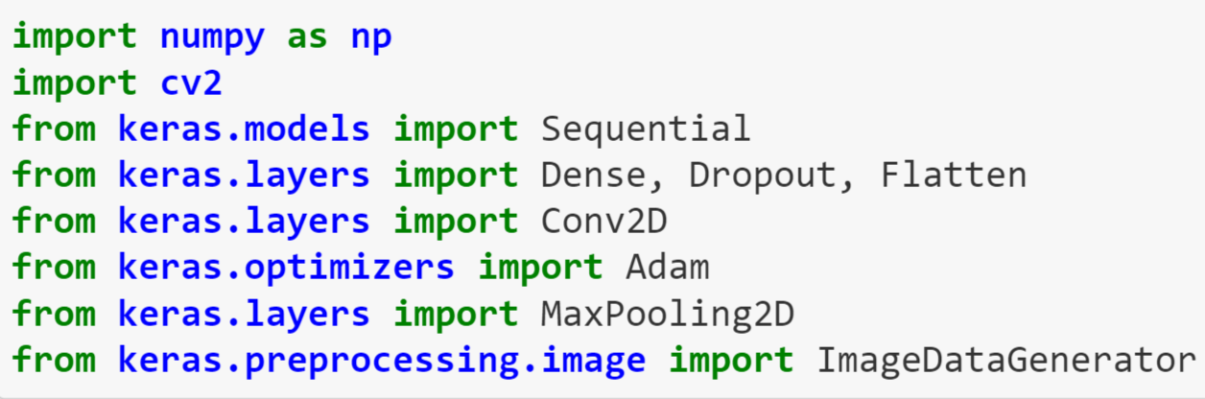

2. **Initializing Training And Test Generators:**

Keras ImageDataGenerator augments the images in real-time while the model is still training. Any random transformation can be applied to each training image as it is passed to the model. This not only makes the model robust but also saves the overhead memory.

When we run this cell, the total records in the output will be the addition of the training and testing data. In our model, we are using 28,709 images in the test and 7,178 images in the test set.

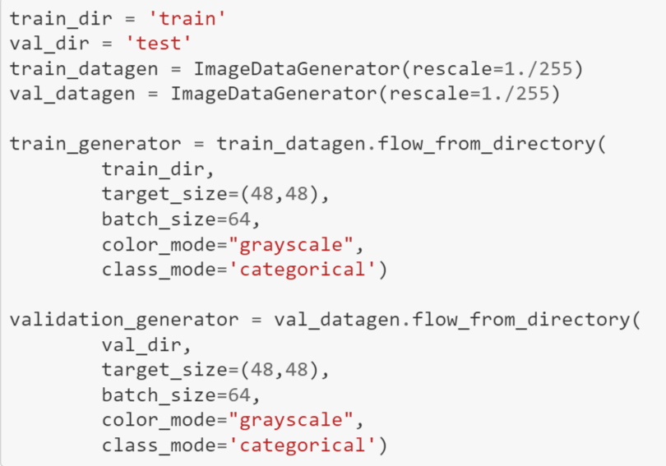

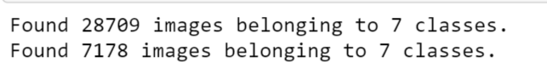

**3.Building the Convolutional Neural Network (CNN) Model:**

ResNet50 also known as Residual Networks is a classic neural network used in many computer vision tasks. The 50 in the ResNet stands for a convolution neural network that is 50-layer deep. The main aim of this model is to avoid poor accuracy as the model becomes deeper. ResNet50 is a pre-trained model on top of which we are going to train our own model.

ResNet model is proposed to solve the issue of diminishing gradient. The basic idea is to skip the connections and pass the residual to the next layer so that the model continues to train. Using this ResNet model on top of our CNN model, our models can go deeper and deeper.

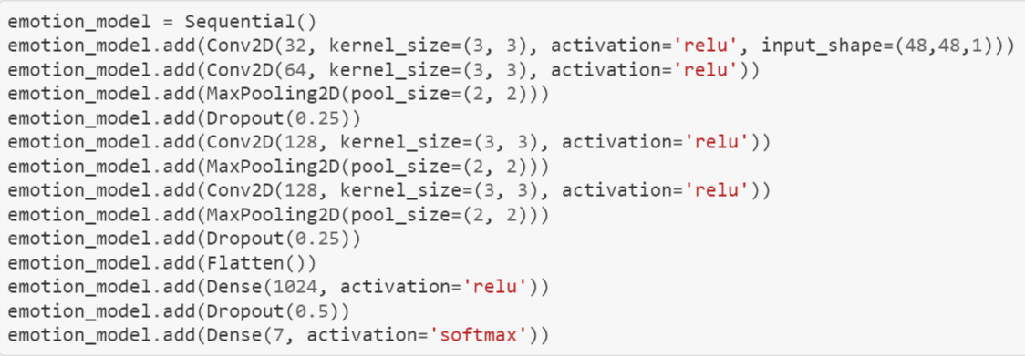

**4. Compiling and Training the Model:**

Categorical_crossentropy computes the crossentropy loss between labels and predictions. Crossentropy loss function is used when there are two or more label classes.

The Optimizer is one of the two arguments required for compiling a Keras model.

In this model, we are using Adam optimizer.

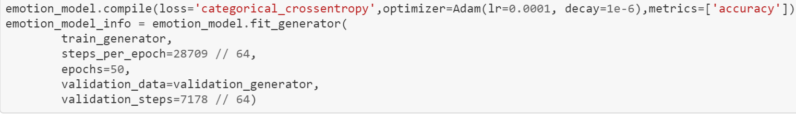

**5.Saving the Model:**

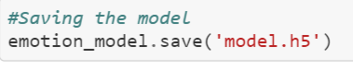

**Now, for testing the model:**

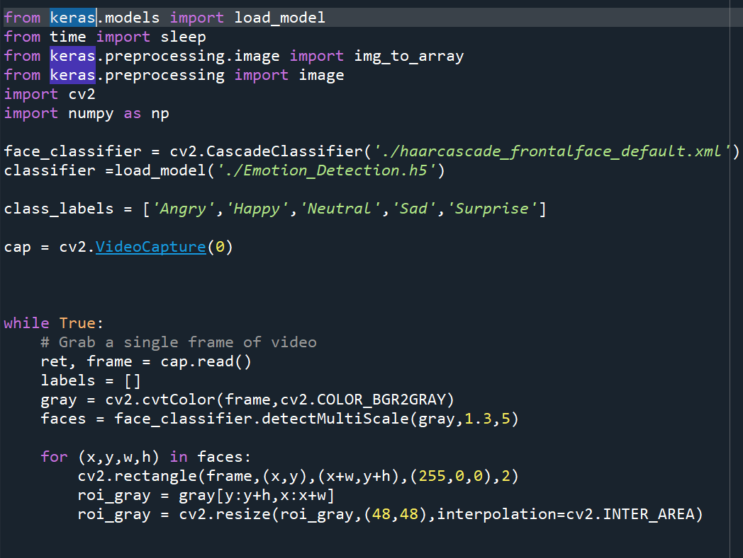

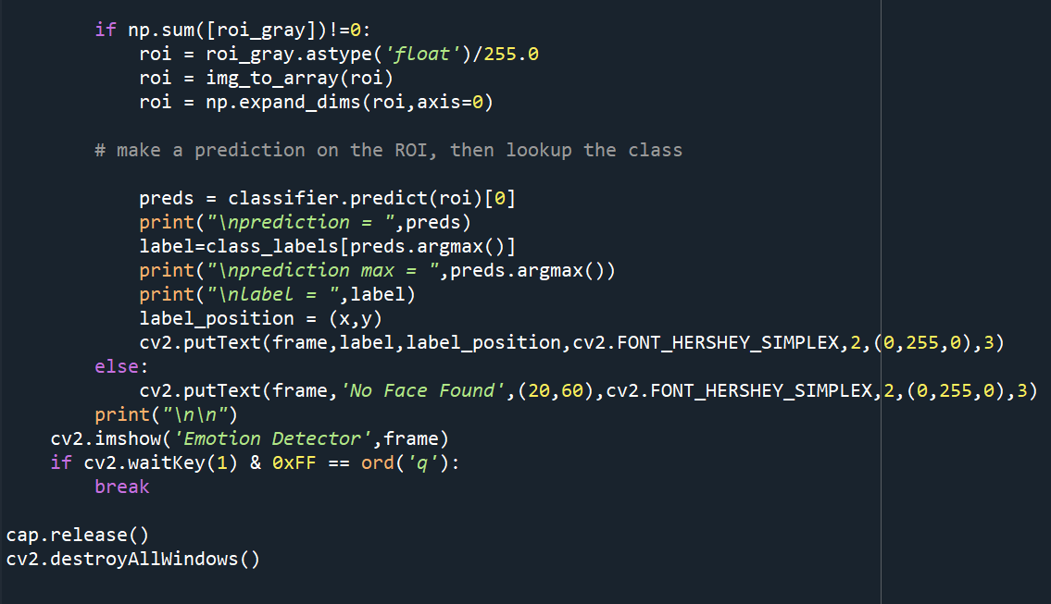

**Complete Code:**

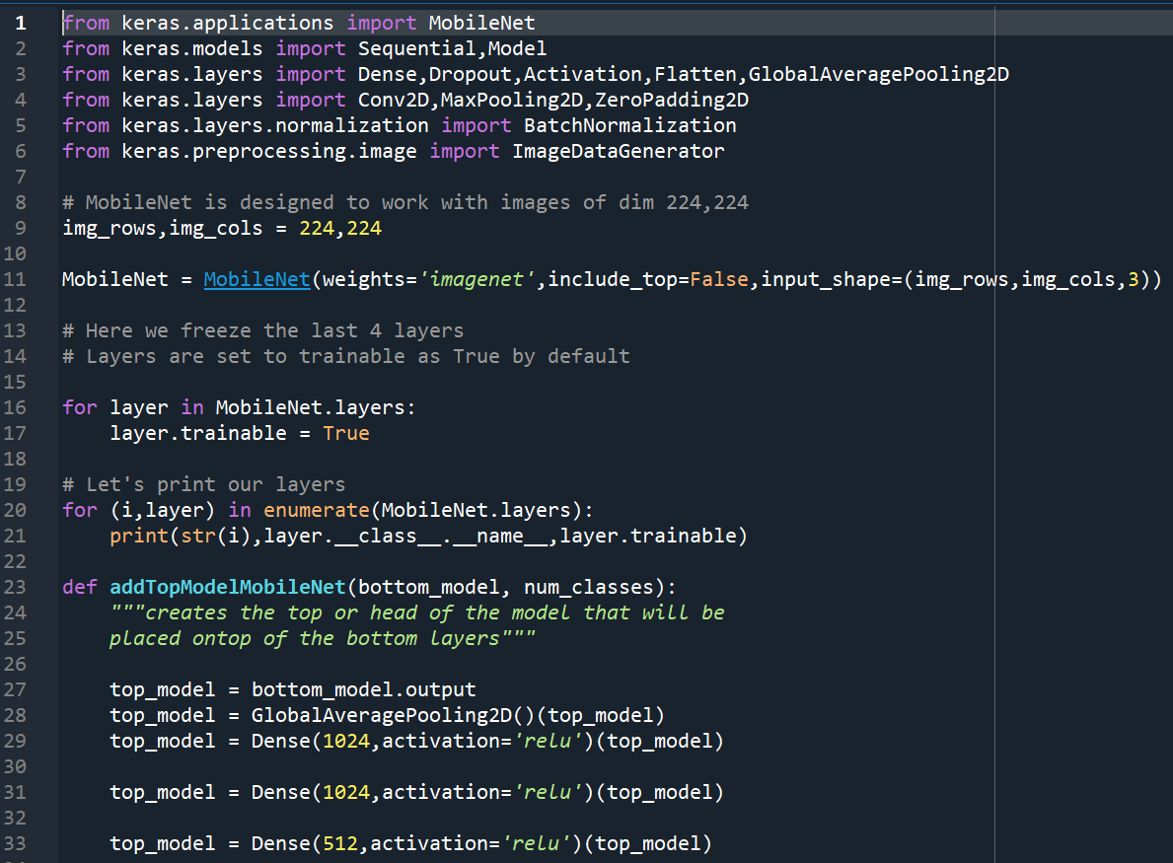

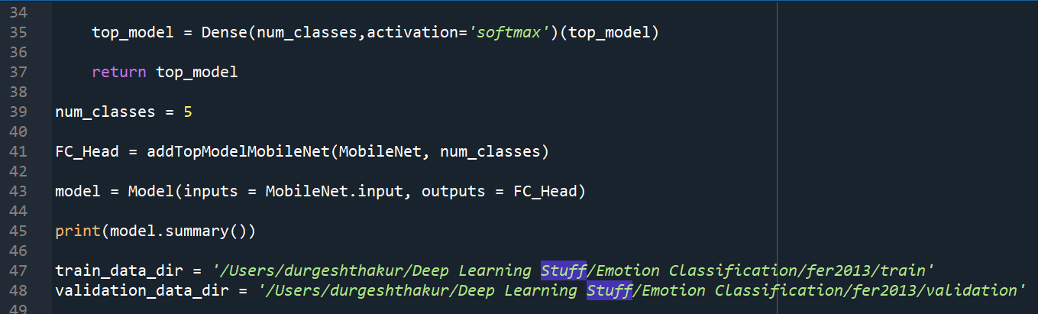

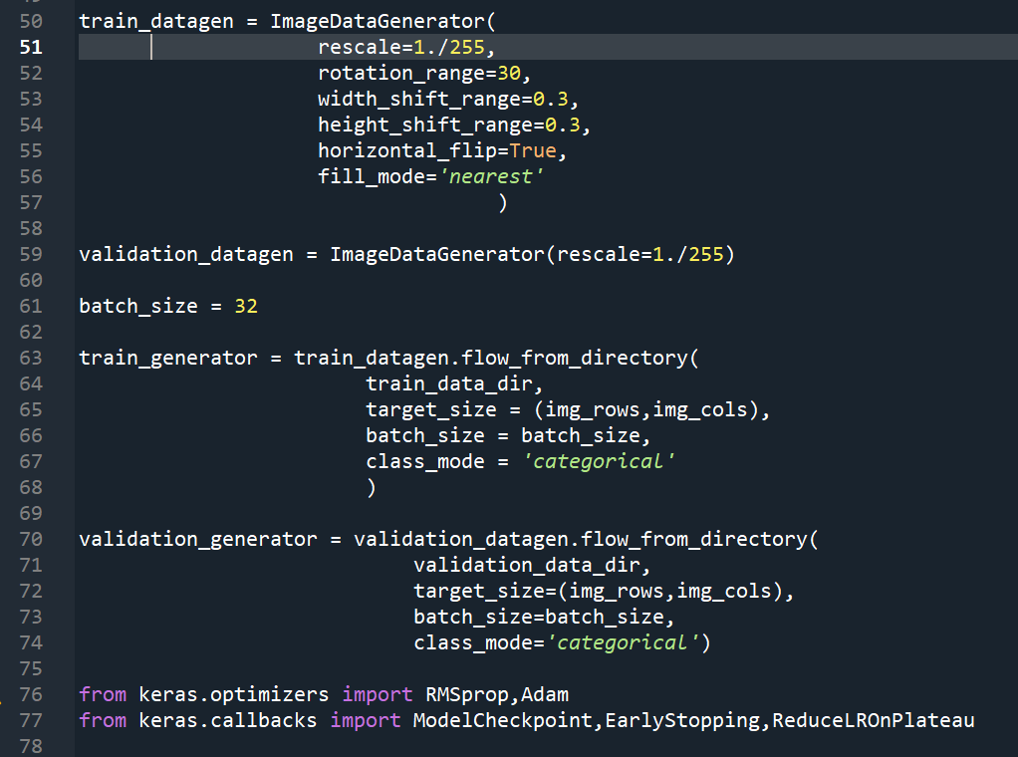

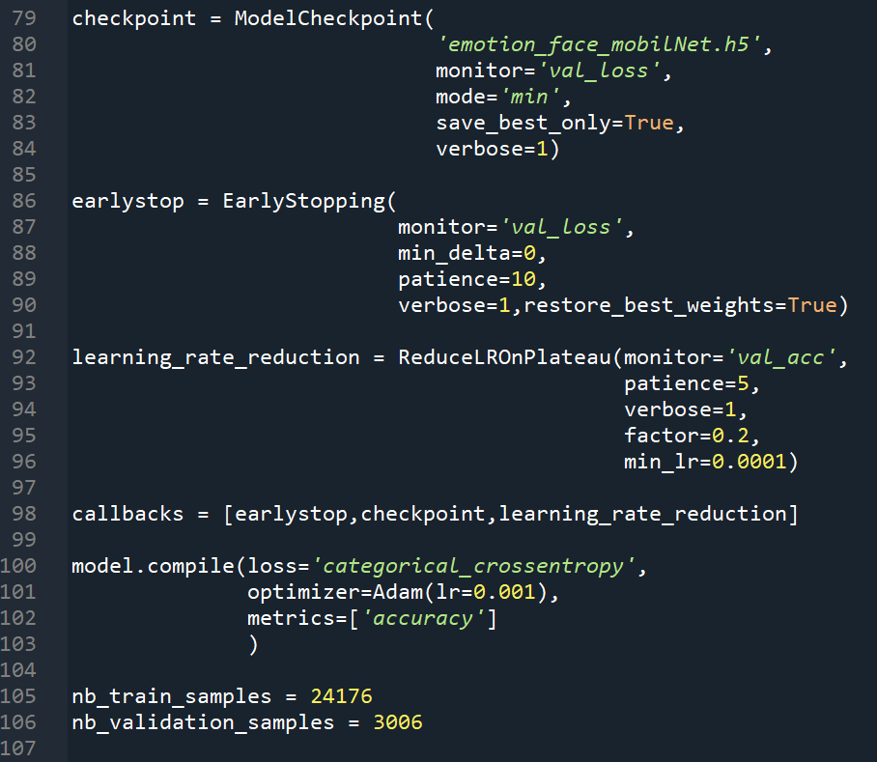

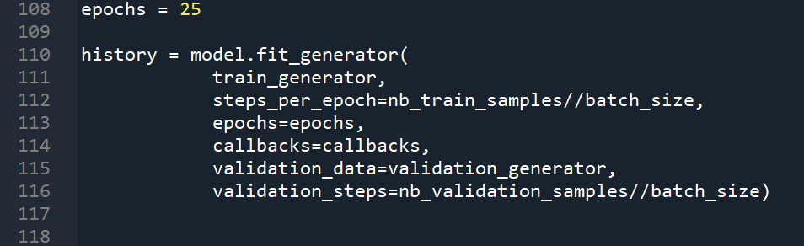

**Test file for output:**

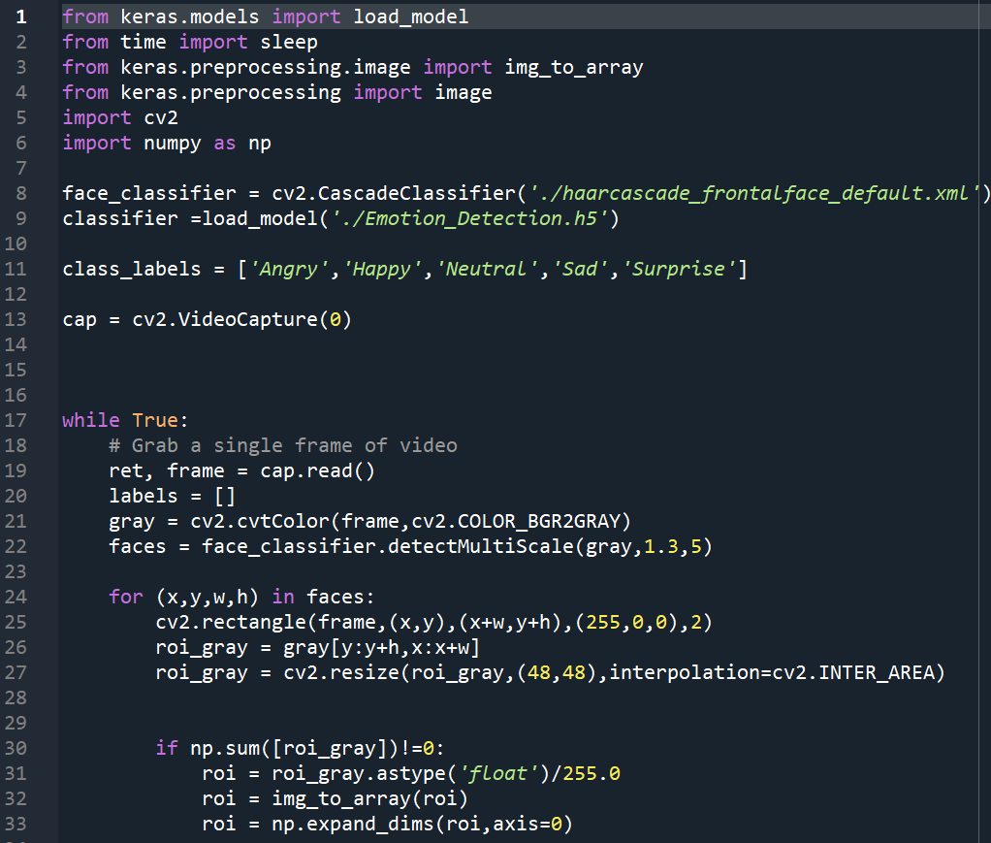

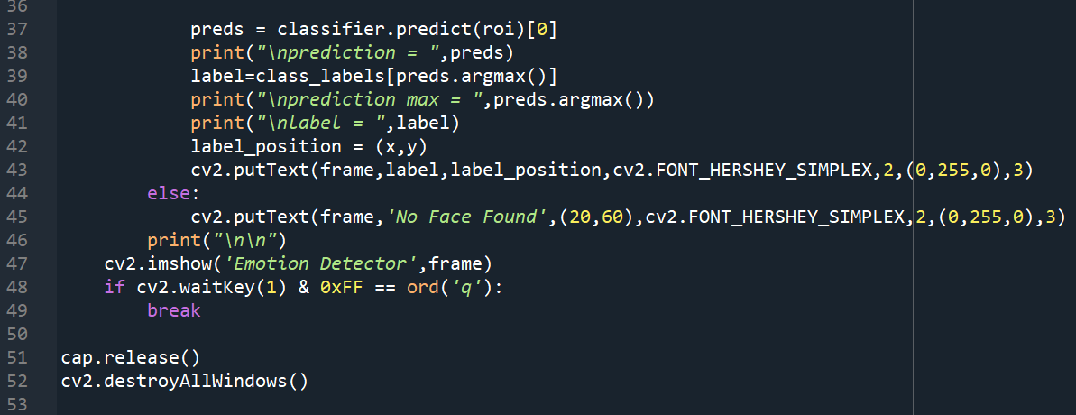

**Output screenshots:**

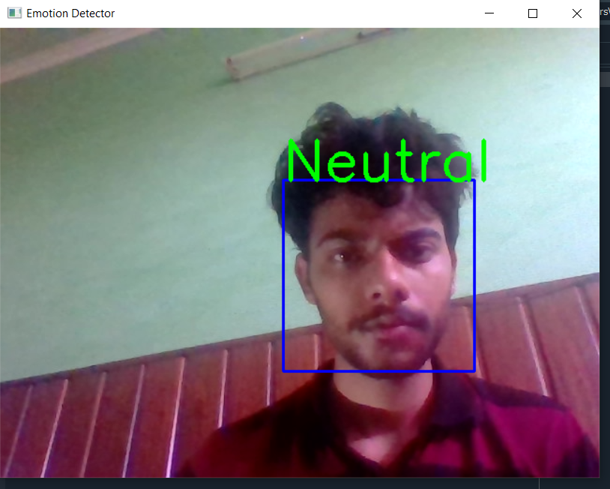

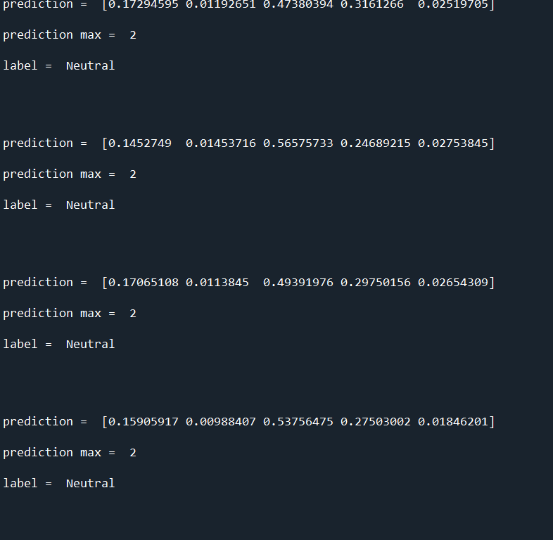

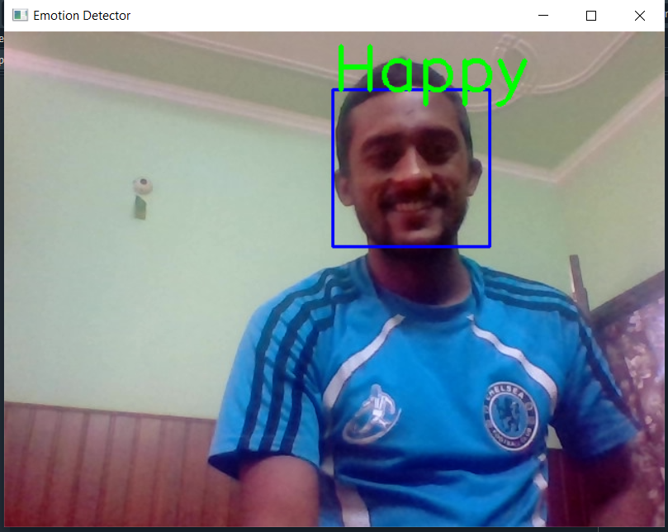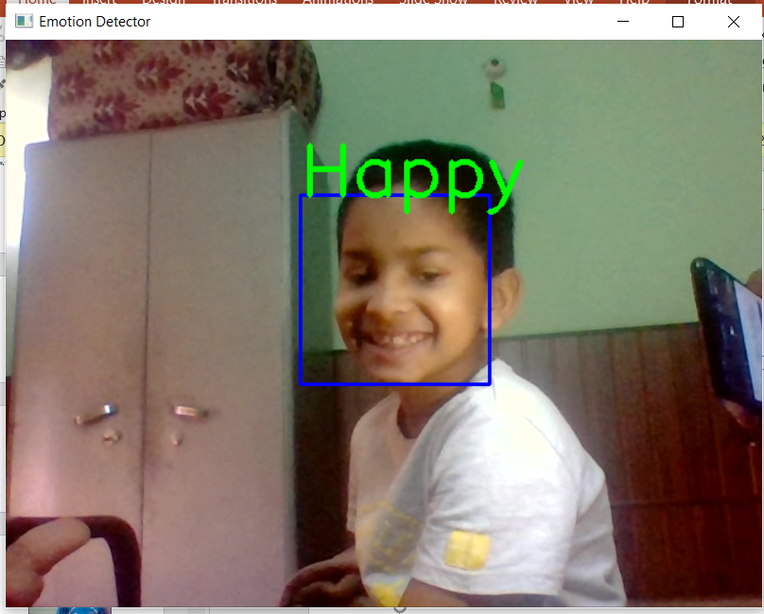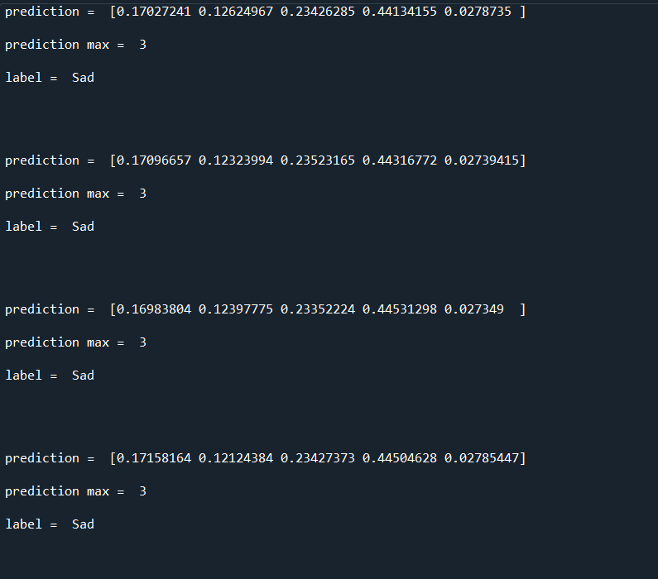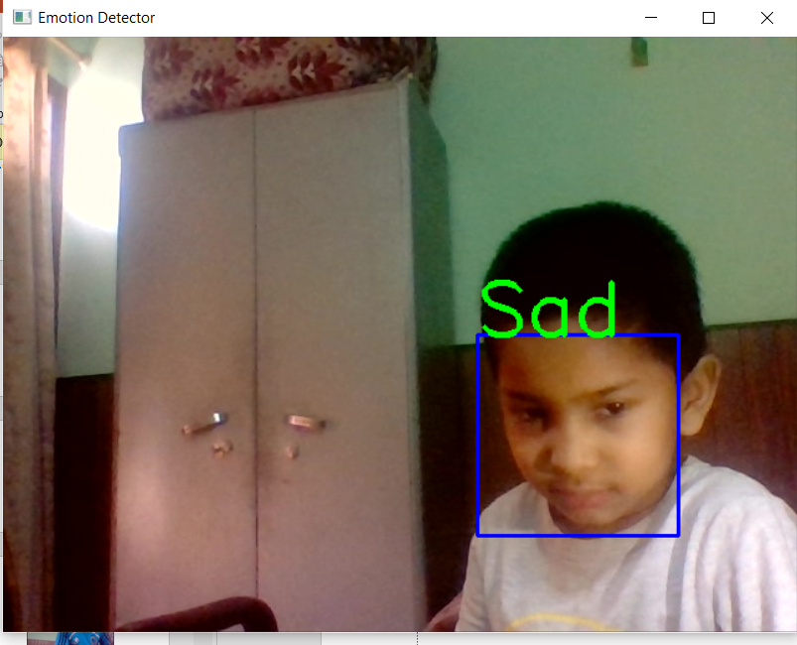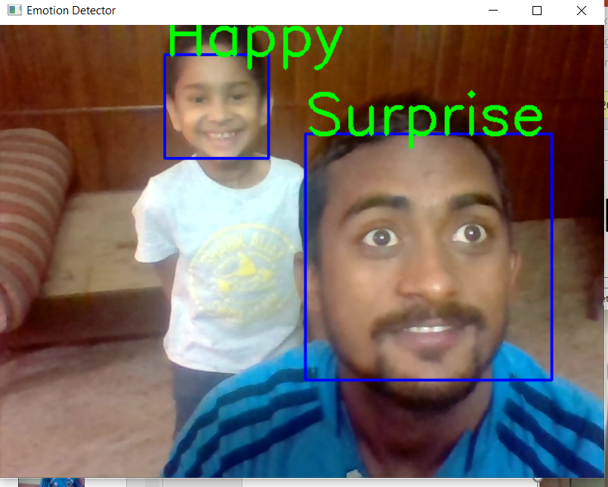

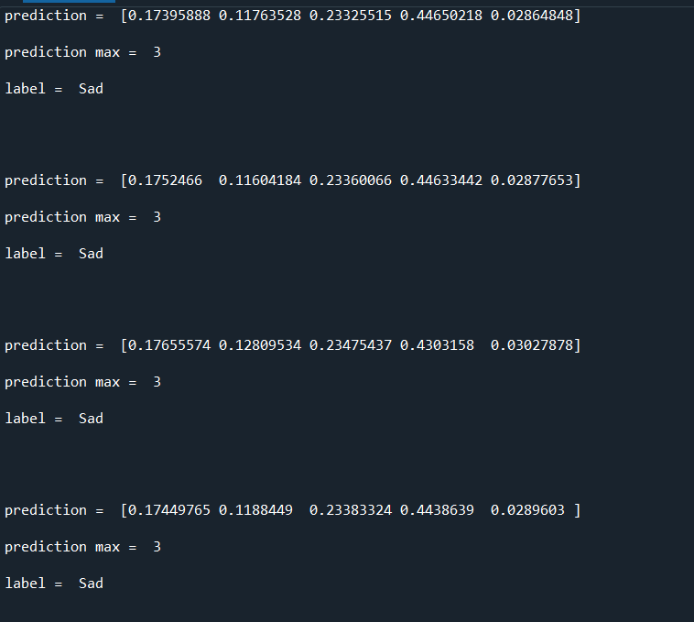

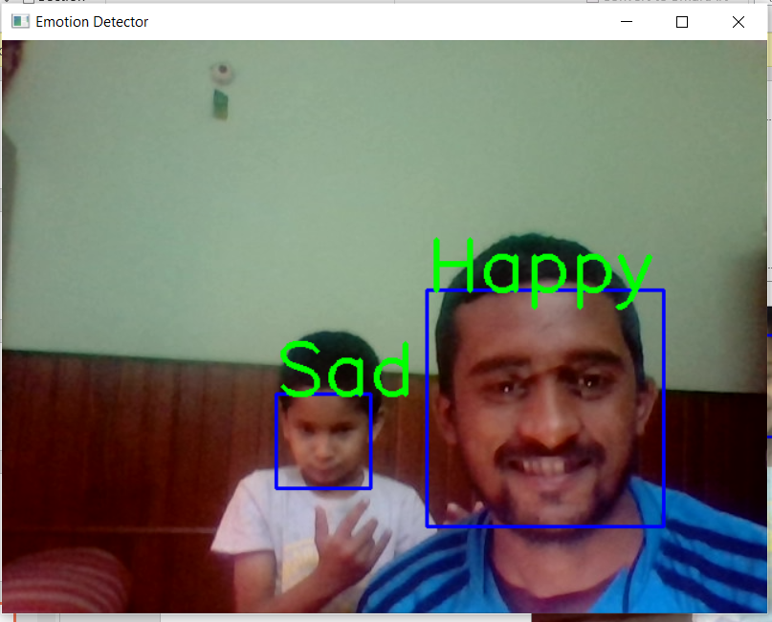

**CONCLUSION:**

Through this project, I have tried to provide brief information on how Emotion Recognition works using Deep Learning. We trained our Convolutional Neural Network Model on top of pre-trained data (ResNet50)and we also used Computer Vision as part of this model. Haarcascade is the package used from OpenCV to detect objects in other images.

We trained the model with several images and then used the test images to see how the results match up. We trained the model through epochs. In this model, we have taken epochs as 100. Once the threshold is achieved by the model and if we further try to train our model, then it will provide unexpected results and its accuracy will also decrease. After that, increasing the epoch would also not help. Hence, epochs play a very important role in deciding the accuracy of the model, and its value can be decided through trial and error.

For this model, the accuracy that we achieved for the validation set is 63%. To further increase the accuracy of the model, we can either expand the training dataset we have or increase the step size for the model. Through these parameters, we can increase the model accuracy for this model.